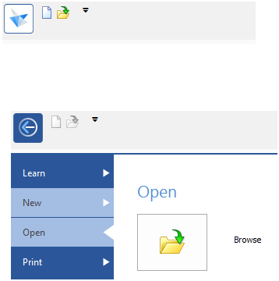

Learn 
Open 
Print 
Share 
Settings 
Tools 
Info 
New 
Edit List. 
Opens the Nevv dialog for creating a nevv document from 
standard or custom templates. 
ANSI Metric Part 
Creates a nevv Part document using the default template. 

Standard Te mplates 
ANSI Inch 
ANS Metric 
DIN Metric 
ESKD Metric 
G8 Metric 
IMPERIAL 
ISO Metric 
JIS Metric 
Metric 
Nailboard 
QuickSheet 
Reports 
Symbol 
UNI Metric 
Edit List... 
ansi metric 
assembl y. asm 
ansi metric 
sheet m 
ansi metric 
n eldmen t. asm 
New 
ansi metric 
draft.dft 
ansi metric 
part. par 

Standard Te mplates 
ANSI Inch 
ANSI Metric 
DIN Metric 
ESKD Metric 
G8 Metric 
IMPERIAL 
ISO Metric 
JIS Metric 
Metric 
Nailboard 
QuickSheet 
Reports 
Symbol 
UNI Metric 
Edit List.. 
ansi inch 
assembl y. asm 
ansi inch sheet 
metal psm 
ansi inch 
neldment. asm 
New 
ansi inch 
draft. dft 
Preview: 
ansi inch 
par t. par 