You are being commission by a company to create a set of engineered drawings for their new and innovative product, a toolbox. The company has developed the prototype but now needs you to create the drawings

Customers’ Requests:

- 3D model of all components
- 3D model of the assembly
- Isometric assembly drawing with a bill of materials
- Individual drawing for each component

Notes and specifications:
- All sheets are to be A wide
- All components are in imperial
- Dimension are in inched
- Title block must be unique to your company

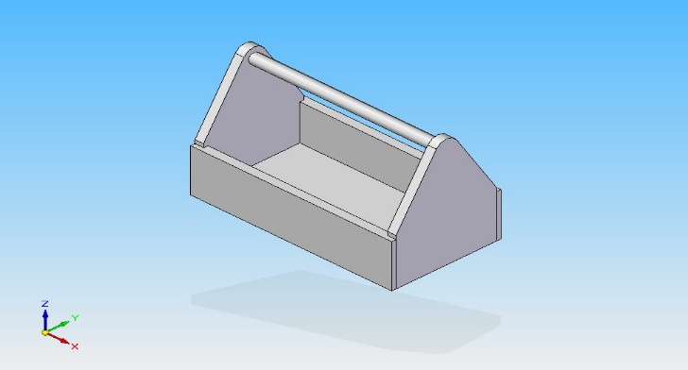

Schedule
To help keep you on track the following can be used as a guide for your time.
Introduction to assignment - 1 period
Measurement and sketching – 2 periods
Create 3D models of the four components – 2 period
Assemble the components – 2 periods
Create engineered drawing – 3 periods

Log Sheets
In the workplace every employee is accountable for his or her time; this usually comes in the form of a Jobsheet/Worksheet Log. It is reviewed by Supervisors and Management to ensure the Job is progressing as scheduled. In this assignment every student is accountable for his/her time and will keep records of this in their weekly log sheets.
These log sheets will be filled out daily and reviewed. Log sheets should recap the day’s events and include information such as were you satisfied with your performance? Were you productive? Were there any major foul-ups? Etc.
Evaluation will be based on the following:
Criteria | Level 1  (50%-59) | Level 2  (60%-69%) | Level 3  (70%-79%) | Level 4  (80-100%)
Communication
Clarity | weekly tasks are reported with limited clarity | weekly tasks are reported with some clarity | weekly tasks are reported with clarity | weekly tasks are reported with limited clarity and are insightful
Detail | content has limited detail | content is somewhat detailed including explanations, tools used, etc. | content is detailed including explanations, etc. | content is very detailed and comprehensive including explanations, tools used, etc.
Spelling/Grammar | log has more than 5 spelling and grammatical errors | log has 3 or 4 spelling and grammatical errors | log has 1 or 2 spelling and grammatical errors | log sheet is free of spelling and grammatical errors.

