General Rules for Dimensioning

- Dimensions should NOT be duplicated, or the same information be given in two different ways.
- No unnecessary dimensions should be used - only those needed to produce or inspect the part.
- Dimensions should be placed at finished surfaces or important center lines.
- Dimensions should be placed so that it is not necessary for the observer to calculate, scale, or assume any measurement.
- Dimensions should be attached to the view that best shows the shape of the feature to be dimensioned.
- Avoid dimensioning to hidden lines wherever possible.
- Dimensions should not be placed on the object unless that is the only clear option.
- Overall dimensions should be placed the greatest distance away from the object so that intermediate dimension can nest closer to the object to avoid crossing extension lines.
- Avoid crossing dimension lines.
- Never cross extension lines.
- A center line may be extended and used as an extension line.
- Leaders should slope at a 30, 45 or 60 degree angle.
- Dimension numbers should be centered between arrowheads, except when using stacked dimensions then the numbers should be staggered.
- In general, a circle is dimensioned by its diameter, an arc by its radius.
- Holes should be located by their center lines.
- Holes should be located in the view that shows the feature as a circle.
- Always dimension the actual size of the object - not the scaled size.
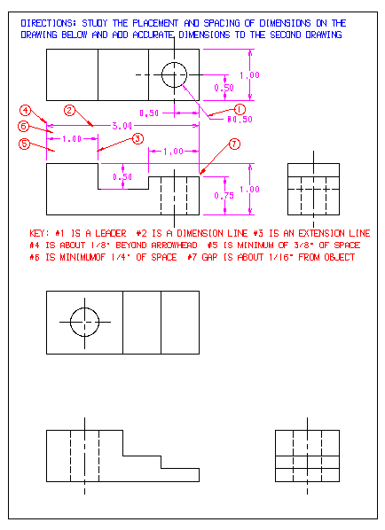

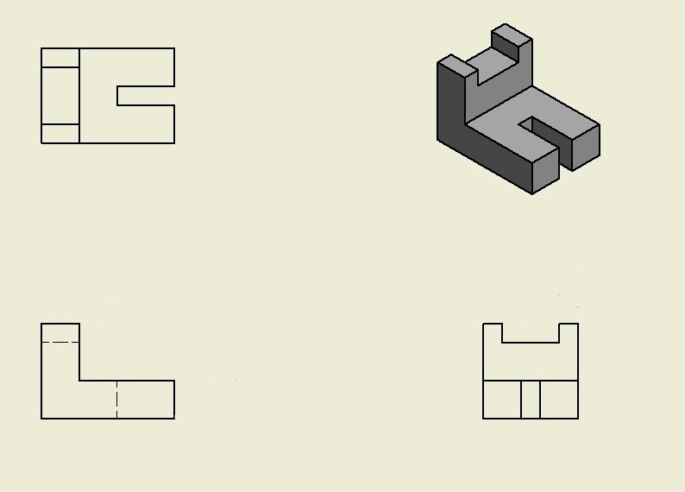
Place all required dimensions baced on the rules
Complete dimensions based completed sample provided by the teacher.

