You are being commission by a family to take the foundation remaining from a fire to recreate their lost family dwelling. Using the attached foundation drawing, your task is to redraw the foundation and within its shell redesign a 2 bedroom, 1 storey home.

Homeowner’s requests:

- 2 bedrooms with master 4 piece ensuite and walk in closet
- Spacious kitchen with island and dinette
- Great Room with gas fireplace
- 3 pc Bathroom
- Large windows on main floor
- Grand entrance with double doors
- Deck off of the rear of house

Notes and specifications:
- All rooms must comply with the Ontario Building Code minimum size
- Basement height is 8’
- Main floor ceiling height is 9’
- Main floor is 4” above grade
- Garage doors are 8’ x 8’
- Door is required from garage to outside
- Exterior must have two different material
- Exterior walls are of 2”x6” construction
- Interior wall are of 2”x4” construction
- Roof must contain two different styles
You are to prepare a series of presentation drawings for the house you have designed.
- Main Floor Presentation including possible furniture and appliance layout as well as the overall square footage.
- Main Floor Working with accurate dimensions
- A 3D pictorial view of exterior of your house design. Remember this view usually shows mature landscaping details. These views are created to show potential buyers what the design would really look like.
- Interior pictures of your house design showing of the features on the inside of your design.

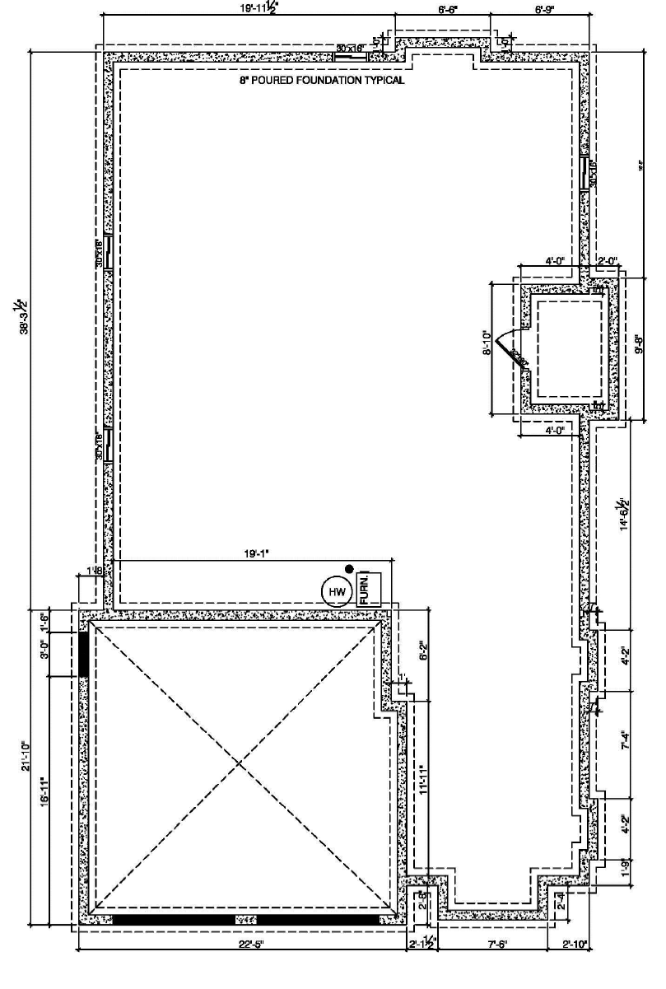

Category | Checklist
Knowledge & Understanding  - drafting conventions and house design elements | - defined living area  - defined sleeping area  - building within required area limits  - room areas meet building code  - hallways and doorways meet building code
Thinking & Inquiry  - basic design criteria | - living room  - dining room or combination dining area  - kitchen  - 3- or 4-piece bathroom  - laundry room  - master bedroom  - bedroom #2
Communication  - presentation and working drawings | - main and second entries indicated  - rooms labelled  - correct use of scale  - area calculations listed by room
Application  - required element | - main floor presentation  - main floor working  - 3D pictorial view of exterior  - interior pictures  - written report

Criteria | Level 1  (50-59%) | Level 2  (60-69%) | Level 3  (70-79%) | Level 4  (80-100%)
Knowledge & Understanding
Drafting conventions and housing design elements  /25 | - demonstrates limited knowledge of drafting conventions and housing design elements | - demonstrates adequate knowledge of drafting conventions and housing design elements | - demonstrates considerable knowledge of drafting conventions and housing design elements | - demonstrates thorough knowledge of drafting conventions and housing design elements
Thinking & Inquiry
Basic design criteria  /25 | - solutions encompass a few of the major design criteria outlined in the design parameters | - solutions effectively encompass most of the design criteria outlined in the design parameters | - solutions effectively encompass all of the design criteria outlined in the design parameters | - solutions effectively encompass all of the design criteria as well as including optional design elements
Communication
Drawing  /25 | - drawings have several omissions of details  - contains multiple errors in scale and proportion | - drawings are mostly complete and accurate, minor omissions  - contains some minor problems with scale and proportion | - drawings are complete with dimensions and required information  - demonstrates considerable accuracy in scale and proportion | - drawings are complete and dimensioned; exceptional additional detail  - demonstrates complete accuracy in scale and proportion
Application
Required elements  /25 | Missing many (>2) elements of the assignment. | Missing some  (2)elements of the assignment | Missing few (1)of the required elements of the assignment | Contains all the required elements of the assignment

/100
Schedule
To help keep you on track the following can be used as a guide for your time.
Introduction to assignment - 1 period
Research Ontario Build Code and adjust room sizes – 1 period
Draw existing foundation and basement– 1 period
Draw new floor plan on foundation – 4 periods
Add interior finishes and furniture and landscaping– 1 period
Finishing touches and written description – 1 period
Log Sheets
In the workplace every employee is accountable for his or her time; this usually comes in the form of a Jobsheet/Worksheet Log. It is reviewed by Supervisors and Management to ensure the Job is progressing as scheduled. In this assignment every student is accountable for his/her time and will keep records of this in their weekly log sheets.
These log sheets will be filled out daily and reviewed. Log sheets should recap the day’s events and include information such as were you satisfied with your performance? Were you productive? Were there any major foul-ups? Etc.
Evaluation will be based on the following:
Criteria | Level 1  (50%-59) | Level 2  (60%-69%) | Level 3  (70%-79%) | Level 4  (80-100%)
Communication
Clarity | weekly tasks are reported with limited clarity | weekly tasks are reported with some clarity | weekly tasks are reported with clarity | weekly tasks are reported with limited clarity and are insightful
Detail | content has limited detail | content is somewhat detailed including explanations, tools used, etc. | content is detailed including explanations, etc. | content is very detailed and comprehensive including explanations, tools used, etc.
Spelling/Grammar | log has more than 5 spelling and grammatical errors | log has 3 or 4 spelling and grammatical errors | log has 1 or 2 spelling and grammatical errors | log sheet is free of spelling and grammatical errors.

