Septic Tanks
Objective
In this lesson we will answer the following questions:
- How do septic systems work?
- What steps must be taken when installing a septic system?
Introduction to Septic Tanks
What Are Septic Tanks?
Septic tanks are an alternative to treatment of wastewater in a wastewater treatment plant. Septic tanks are often used in rural areas to deal with the small amount of sewage created by a single household. The advantages of septic tanks include minimum maintenance and minimum skills required for operation.
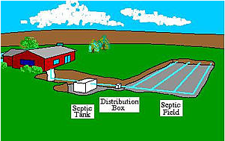

A septic tank is part of a septic system, a diagram of which is shown above. In a septic system, wastes from the home flow down sewer lines into a tank or concrete box - the septic tank. In this tank, solids settle to the bottom and are treated by anaerobic action. The liquid drains off the top into another pipe which runs to a distribution box. From here, the liquid is distributed into fill lines in a septic field. The fill lines allow the water to leak out into the surrounding soil over a large area. As the water slowly percolates down into the groundwater, it is cleaned naturally.

In the Tank
Due to the low velocity of the wastewater flowing into a septic tank, the solids settle to the bottom. Any grease or oil rises to the surface. The clear liquids (known as supernate) are allowed to flow out of the tank to the distribution box and then to the septic field.
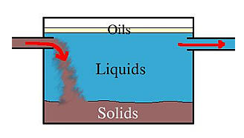
The environment in the septic tank is kept at a pH of 7. Since the water is not aerated, the free oxygen in the water is quickly used up. This results in a perfect habitat for anaerobic bacteria. These bacteria slowly and continually "eat" the solids at the bottom of the tank.
You may remember from the last lesson that respiration can be summarized by the following formula:
However, when anaerobic bacteria break down carbohydrates, they do so using a slightly different method. Rather than producing carbon dioxide and water as byproducts, they produce other gases. These gases include the foul-smelling methane and hydrogen sulfide.
The septic tank is designed so that methane and hydrogen sulfide, as well as water vapor and carbon dioxide, can escape from the septic tank through a stink-pipe, or vent, attached to the outside of the residence. The stink-pipe prevents the gases from building up in the tank and from causing an unpleasant odor around the tank.
The Supernate
The supernate flows out of the septic tank and into a distribution box, which must be constructed so that all of the lines from the septic tank receive equal amounts. From the distribution box, the supernate is transferred to the fill lines and absorbed into the soil.

Maintenance
The need for only minimal maintenance is one of the major benefits of septic systems. Most septic tanks are energy efficient because little energy is required for operation. The initial installation of building and installing the tank, distribution box, and lines are the major energy users. Preventing plant growth on the septic field is the most energy required for maintenance after installation.
Tree must not be allowed to grow over septic tank systems. Leaves from trees overhanging the septic field can clog the septic lines.
Grass must be mown above the septic field. This prevents brush and small trees from growing in the field. These plants could sink their roots down into the septic lines and break them.
Installation
Permeability Testing
The supernate from a septic tank is not as clean as the water released by wastewater treatment plants. This supernate would pollute streams and the groundwater if it came in contact with them before trickling down through the soil. As a result, soil permeability must be carefully tested before installing a septic system. Permeability refers to how easily water can trickle down through soil.
Septic systems do not work well in clay soils since these relatively impermeable soils do not allow the supernate to soak in. Instead, if a septic system is installed in a clay soil, the supernate often rises to the surface of the ground, producing an obviously unsanitary situation.
The Health Department has established soil testing procedures which must be followed before a septic tank can be installed. These procedures test the permeability, or perk, of the soil. The procedure is outlined below:

1. A 2 feet deep hole is dug in the soil.

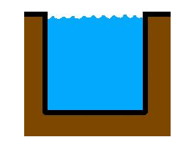
2. The hole is saturated with water. Then the hole is filled with water to a known depth.
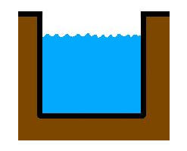
3. The water is allowed to sink into the soil for 30 minutes. After thirty minutes, the depth of the water in the hole is measured.

The perk value is then calculated as follows:
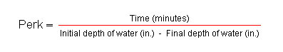
So, if the water in the hole above was initially filled to a depth of 18 inches and, after thirty minutes, sunk down to 16 inches, the perk value would be:
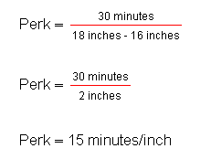
Perk values between 10 and 100 indicate usable soil, so the ground we tested above is permeable enough to be used for a septic system.
Higher values, between 110 and 125, indicate relatively impermeable soils. Septic systems can be placed in these soils if additional septic lines are installed. But if perk values are greater then 125, then the soil is impermeable and the Health Department will turn down any application for a permit.
Very permeable soils can also be a problem since the septic system will not hold water long enough for it to be properly treated. Sandy loam soils, often found near rivers, have a perk value of less than 10 and are unsuitable for septic systems. These areas are also likely to have a high water table which can force the sewage to the surface and cause unsanitary conditions.
Tank Size
Once the soil has been tested and the Health Department has issued a permit, the septic system can be installed. The first factor to be considered is the size of the tank.
The size of the tank will depend upon the size of the family and the type of use to which the tank will be put. A larger family will create more waste and will require a larger tank. Households which use their tanks for garbage disposal will also require a larger tank.
The amount of available land will also influence which tank size is chosen.
Fill Line Installation
After the septic tank has been chosen and installed, the septic field must be put in place. Laying down the fill lines in the septic field is somewhat similar to laying down distribution lines in the water treatment system. But in addition to cushioning the fill lines, they must be installed so that the water can continuously flow out of the lines and into the soil without clogging and backing up.
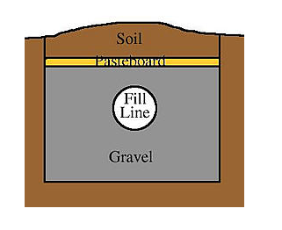
Gravel is placed below, around, and above the lines to prevent soil from clogging the lines. Above the gravel is a layer of pasteboard. Then soil is filled back in above the pasteboard and is packed to the original surface contour.
The pasteboard is important to keep soil from filtering down into the gravel and clogging the fill lines. Over time, the pasteboard will rot away, but that is not a problem because by then the soil above will have stabilized and will not fall down into the gravel.
As we have mentioned previously, water flows out of the fill lines and trickles down through the soil. Once the pasteboard rots away, water can also come up through the top of the fill pipe and out of the surface of the soil. In non-permeable regions such as some areas in the Appalachians, 60% of the water comes to the top of the ground and will be dispersed through transpiration (breathing) of plants. The other 40% will become groundwater.
Septic Fields on Hills
The last consideration when installing fill lines is that the supernate must be distributed evenly across the ground. When the ground is sloped, then the lines should be connected in parallel or in series to provide efficient removal.
The lines should also be placed so that they are perpendicular to the slope of the land. Another way of saying this is that the fill lines should be parallel to the contour lines of the land.
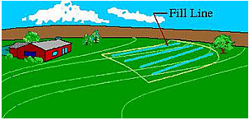
In the drawing above, the house is sitting on top of a hill and the septic field (outlined in yellow) is to be placed on the side of the hill. Contour lines have been drawn on the hillside in pale green. You can see that the fill lines roughly parallel the contour lines of the hill.
You can imagine what would happen if the fill lines were installed perpendicular rather than parallel to the contour lines of the hill. The supernate would all flow quickly to the end of each fill line and would then flow into the soil all at the bottom of the hill. This would not evenly distribute the supernate through the soil.
Review
Septic tanks are an alternative to wastewater treatment plants in rural areas. After the initial expense of installing the system, mowing grass and removing trees are the only maintenance required to operate the septic systems.
Septic systems consist of:
- a septic tank, where the sewage collects and is treated by anaerobic action,
- a stink-pipe, through which gases escape from the septic tank,
- a distribution box, where the supernate collects,
- and a septic field, where the supernate is evenly distributed into the ground.
The first step in installing a septic system is to test the permeability of the soil. Then the Health Department issues a permit. The septic tank is chosen and installed, then the septic field is put in place.

