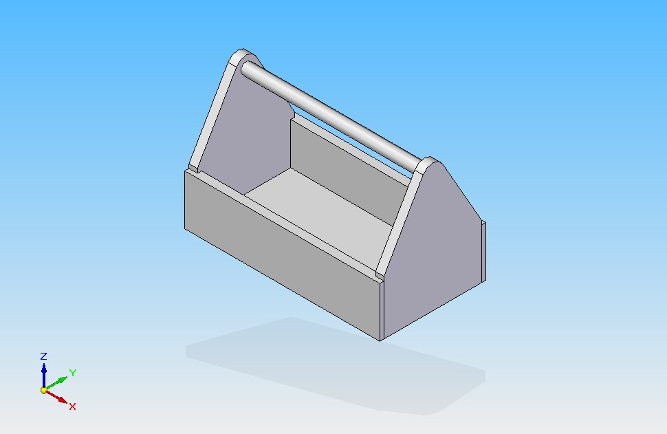
Toolbox Project

Tools/Equipment Required
Mitre Saw
Table Saw
Jointer
Planer

Pipe Clamps, Glue
Router
Drill Press
Belt Sander

Keep this worksheet during the build and use the checkboxes to track your progress.

Process I – Side Panels
- Create a laminated panel using salvaged boards
- Finish the panels to the overall size to print (Thickness, Width, Length)
- Layout & Cut Rabbet joints on the CNC router to accept end panels
- Layout & Cut Dado joint on the CNC router to accept bottom panel
- Sand the faces to a smooth finish

Process II – End Panels
- Create a 2 laminated panels using salvaged boards
- Square both panels then glue together
- Finish the panel to the overall size to print (Thickness, Width, Length)
- Layout the hole, dado, & pattern
- Drill the blind hole to accept the handle
- Cut the Dado joint on the CNC router to accept the bottom panel
- Cut the pattern using the bandsaw leaving adequate sanding material; sand the pattern to a fine finish

Process III – Bottom Panel
- Create a 2 laminated panel using salvaged boards
- Square both panels then glue together
- Finish the Overall size to print (Thickness, Width, Length)
- Sand to a smooth finish

Process IV – Handle

- Cut a piece of dowel stock to length
- Turn design on lathe (optional)

Process V – Assembly

- Dry fit the assembly and “fine-tune” the material as necessary
- Prepare clamps, then add glue carefully making sure to wipe off ALL OVERSPILL.
Any residue will show through staining & look sloppy & unprofessional
- Choose a stain by trying it out on a small sample piece of scrap
- Stain (allow 24 hrs to dry) then Varnish your project. Wipe off excess and be sure there is no pooling. Allow adequate time to dry and then submit for evaluation

CONGRATULATIONS!!! Good work

